* Open the invitation email and login to FlexKB with the username and temporary password in the email

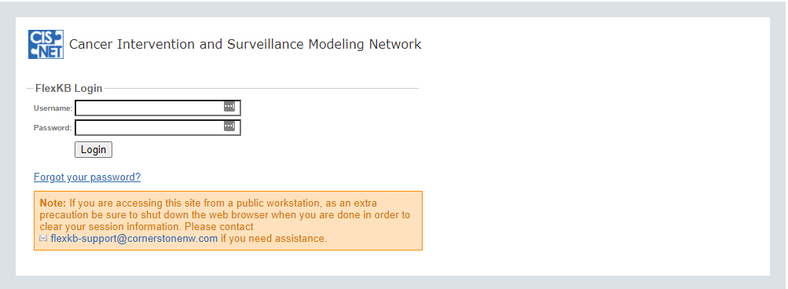

* After logging in for the first time, you will be asked to change your password and set up a security question

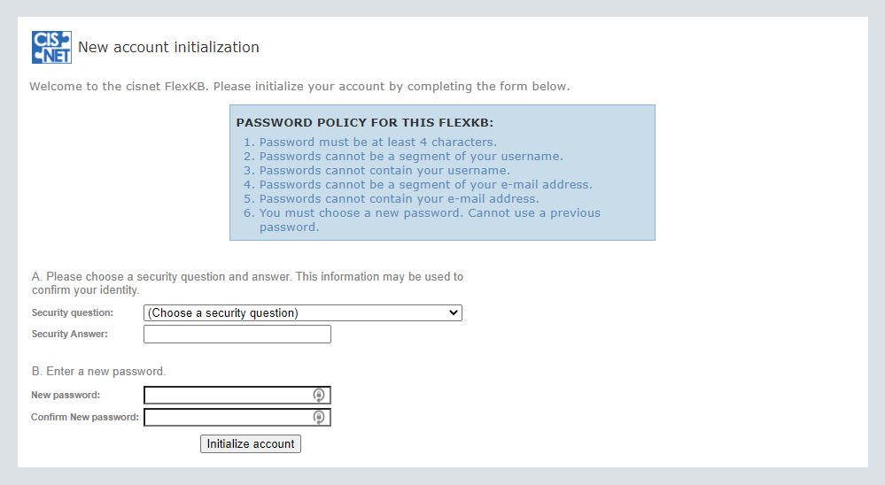

* After setting up your new password and security questions, you will be redirected to the login page where you can login with your new password
* After logging in you will be presented with an end-user agreement. Read through the agreement and click ‘I agree’ to continue to the website

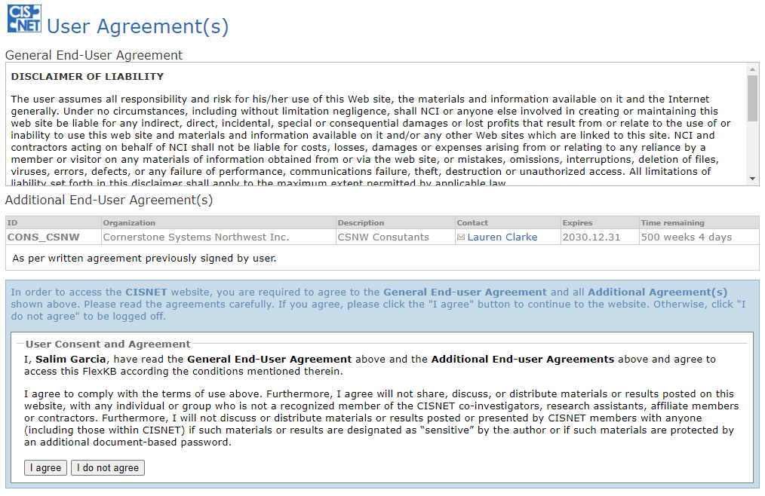

* After clicking ‘I agree’ you will be redirected to the CISNET Interactive Website

